



file 5602718: Average machine count per day is: 2.917

file 5602718: Standard deviation is: 2.712





file 5173312: Average machine count per day is: 3.000

file 5173312: Standard deviation is: 3.275

 

file 9863260: Average machine count per day is: 8.500

file 9863260: Standard deviation is: 18.273

 

file 1325920: Average machine count per day is: 3.250

file 1325920: Standard deviation is: 3.279

file 1212281: Average machine count per day is: 2.833

file 1212281: Standard deviation is: 4.064

file 8155252: Average machine count per day is: 2.083

file 8155252: Standard deviation is: 1.782

file 7259146: Average machine count per day is: 2.000

file 7259146: Standard deviation is: 3.162





file 5904604: Average machine count per day is: 2.833

file 5904604: Standard deviation is: 2.250

file 11469819: Average machine count per day is: 2.083

file 11469819: Standard deviation is: 2.314

9717952

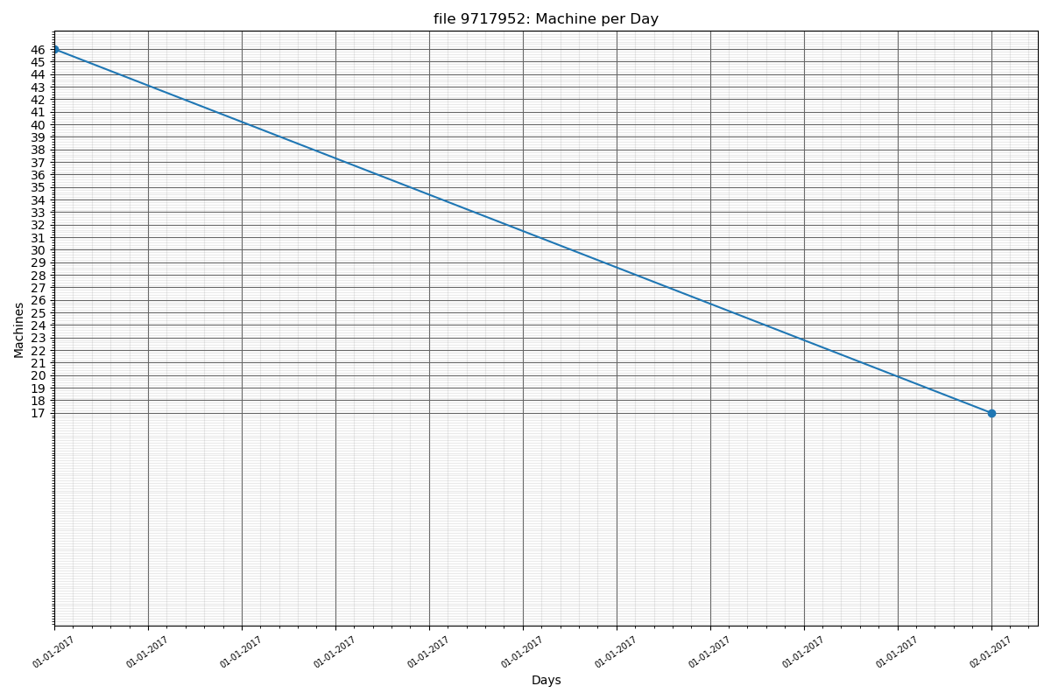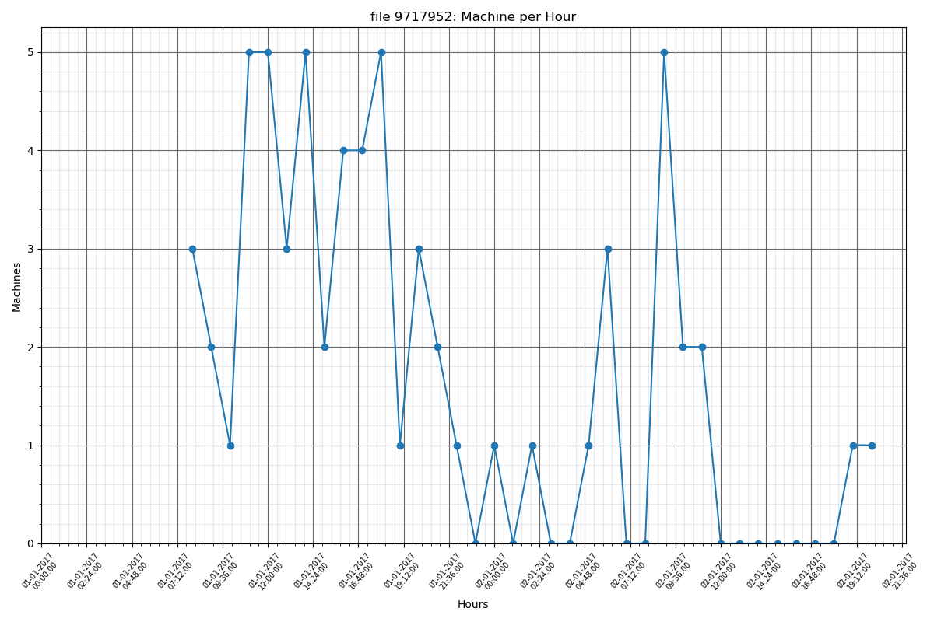

file 9717952: Average machine count per day is: 5.250

file 9717952: Standard deviation is: 13.732

4898681

file 4898681: Average machine count per day is: 5.667

file 4898681: Standard deviation is: 13.480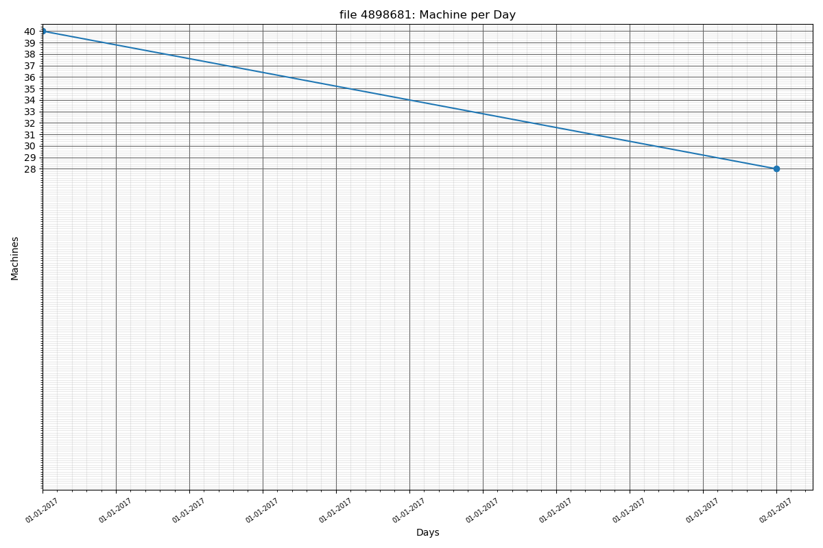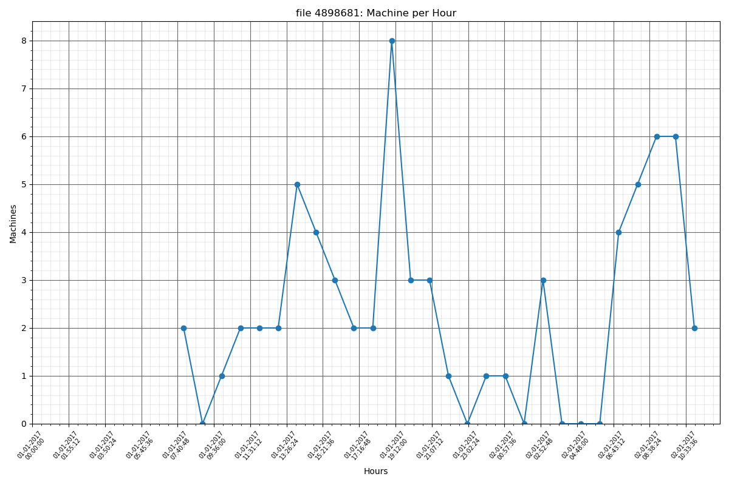

4628840

file 4628840: Average machine count per day is: 2.833

file 4628840: Standard deviation is: 6.631

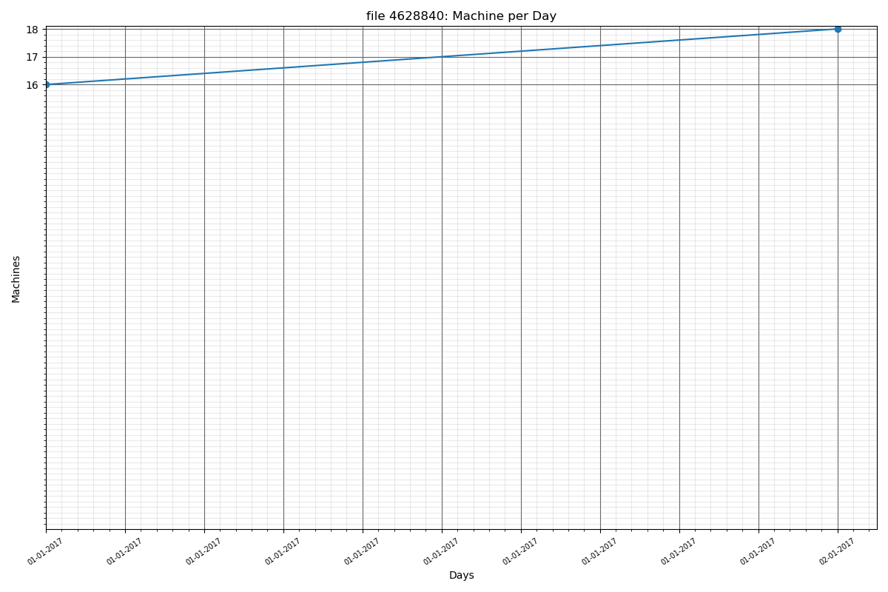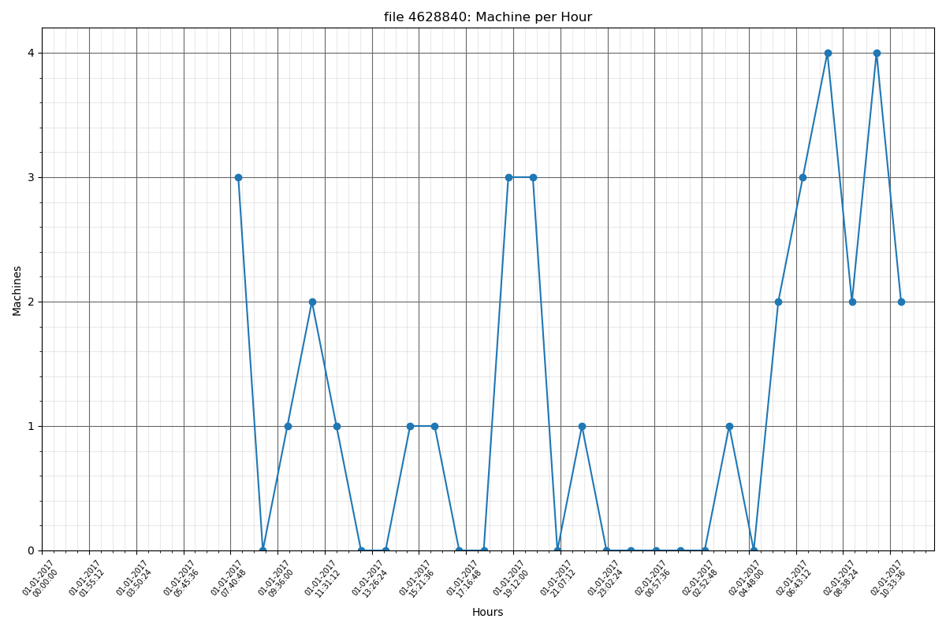

1625753

file 1625753: Average machine count per day is: 1.917

file 1625753: Standard deviation is: 5.265

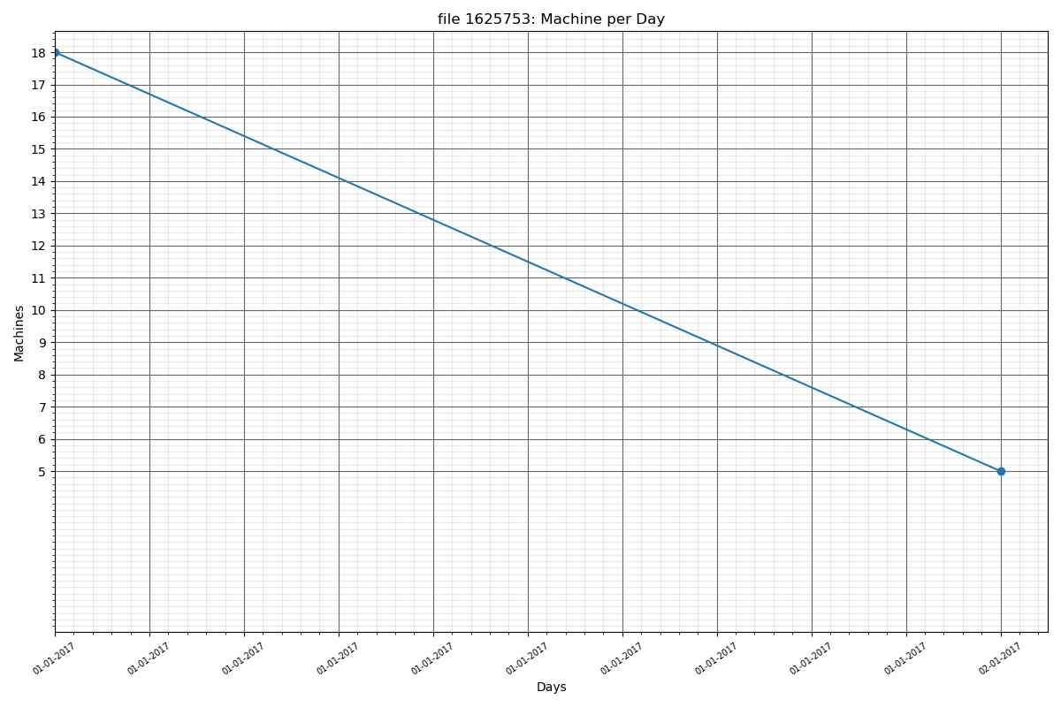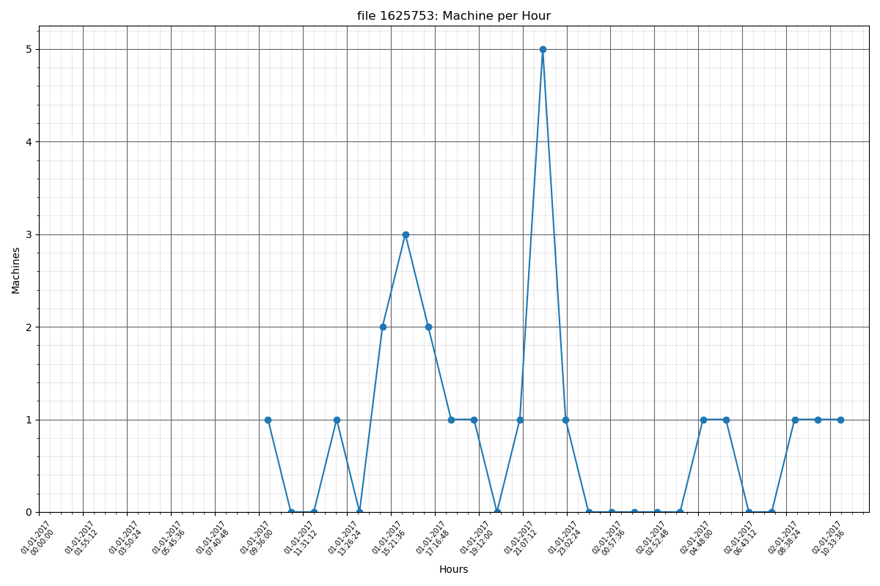

5001896

file 5001896: Average machine count per day is: 1.250

file 5001896: Standard deviation is: 2.927

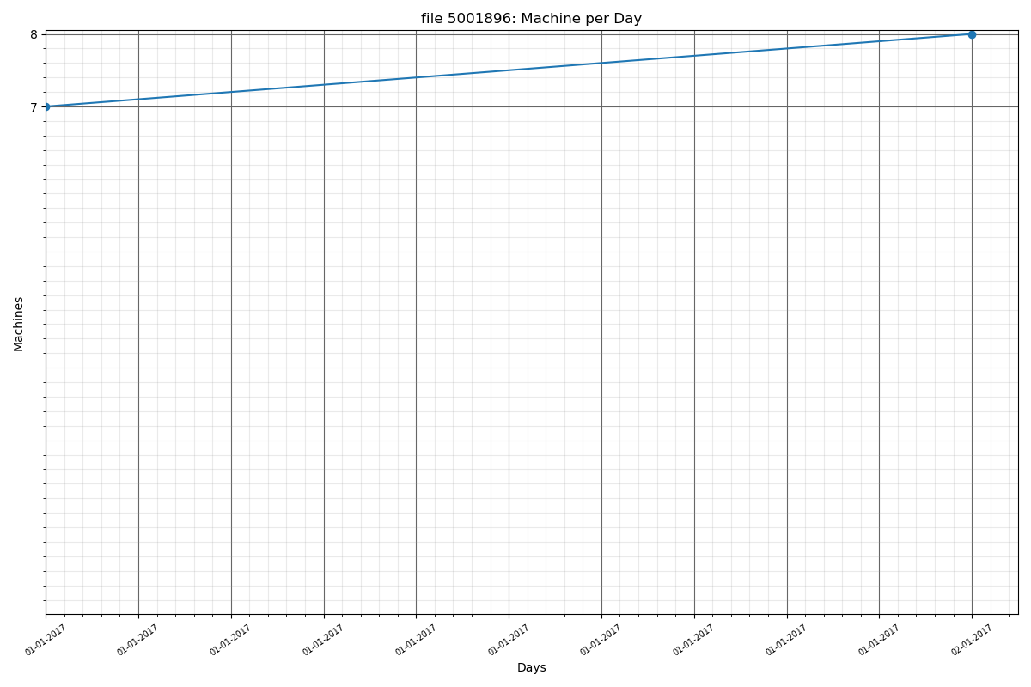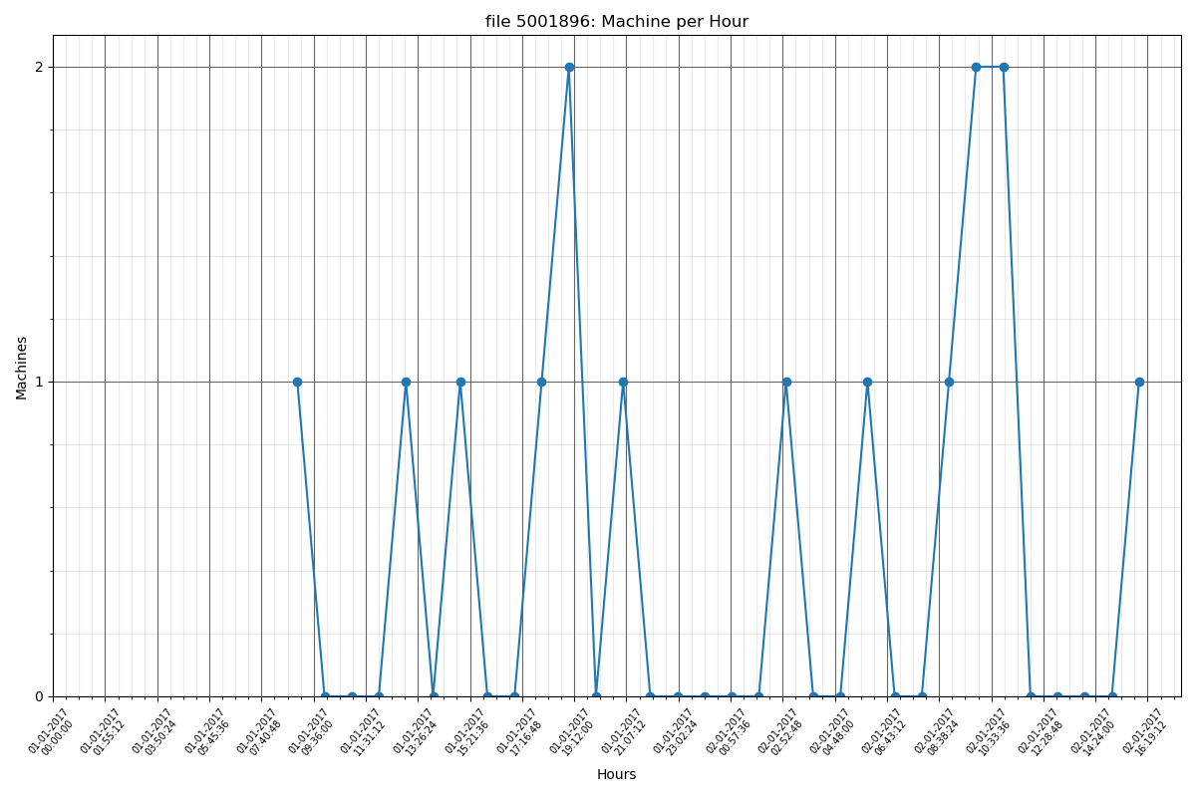

4676898

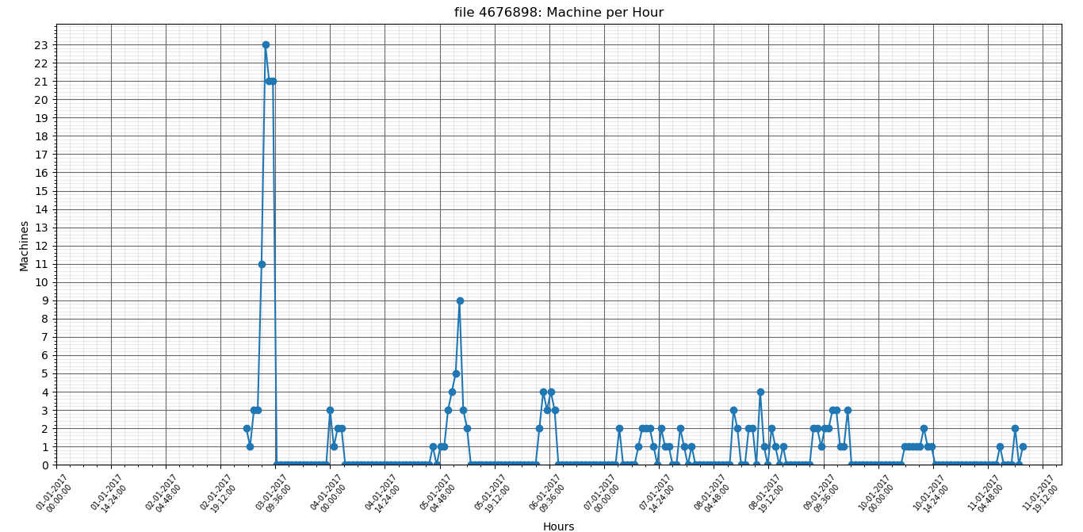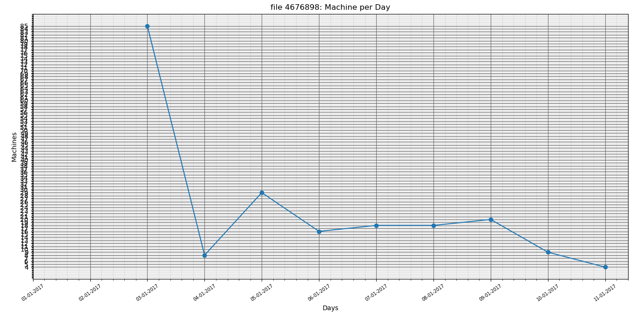

file 4676898: Average machine count per day is: 17.250

file 4676898: Standard deviation is: 23.277

9717952

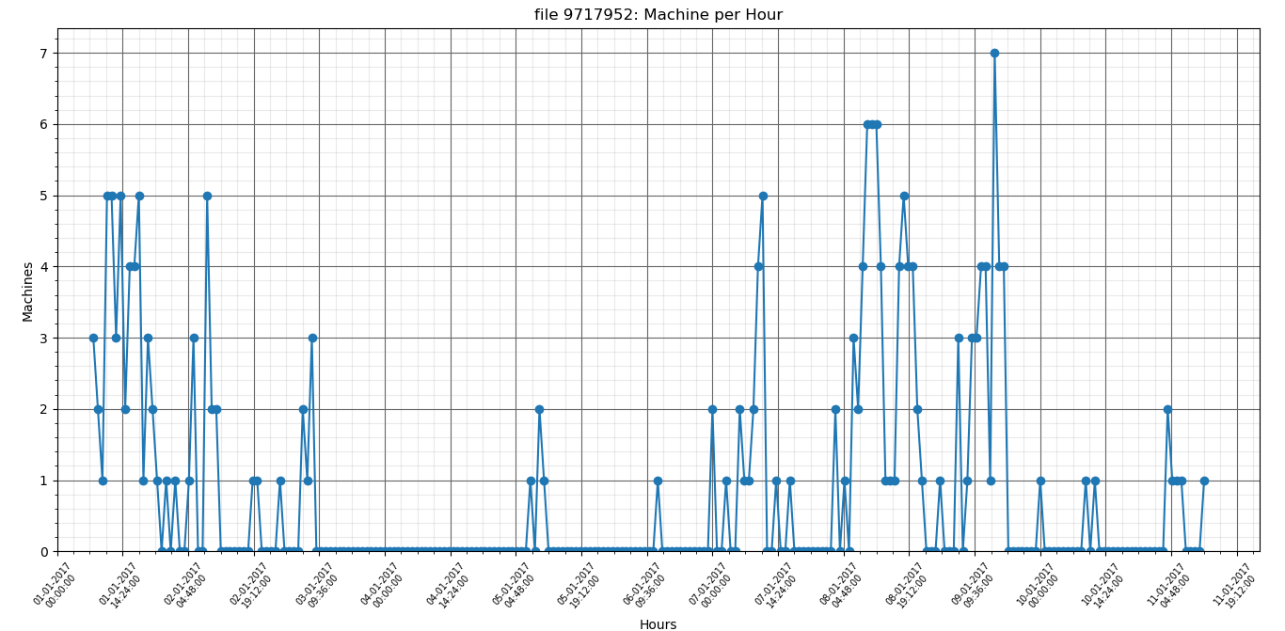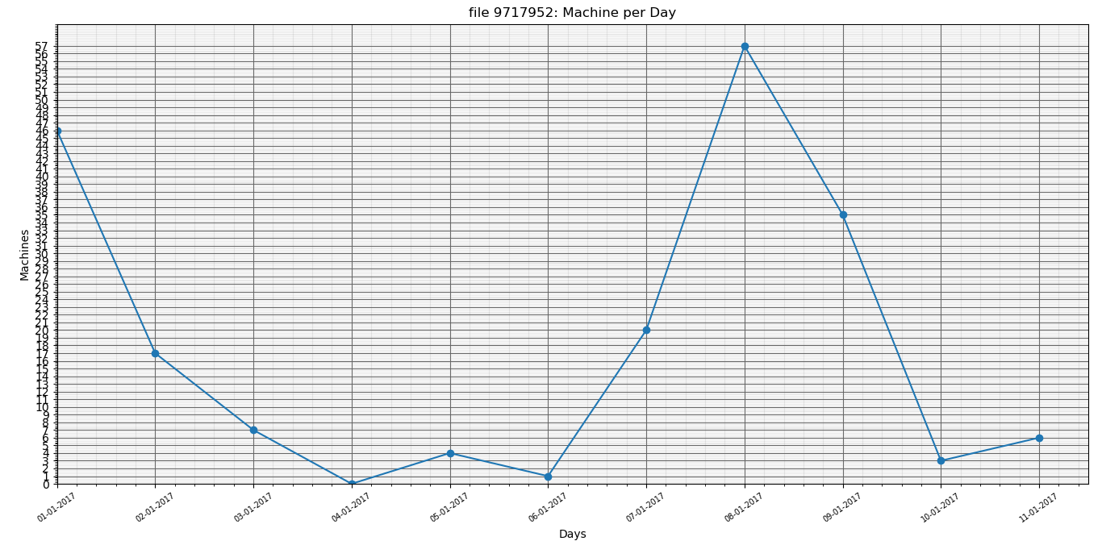

file 9717952: Average machine count per day is: 16.333

file 9717952: Standard deviation is: 19.514

6637411

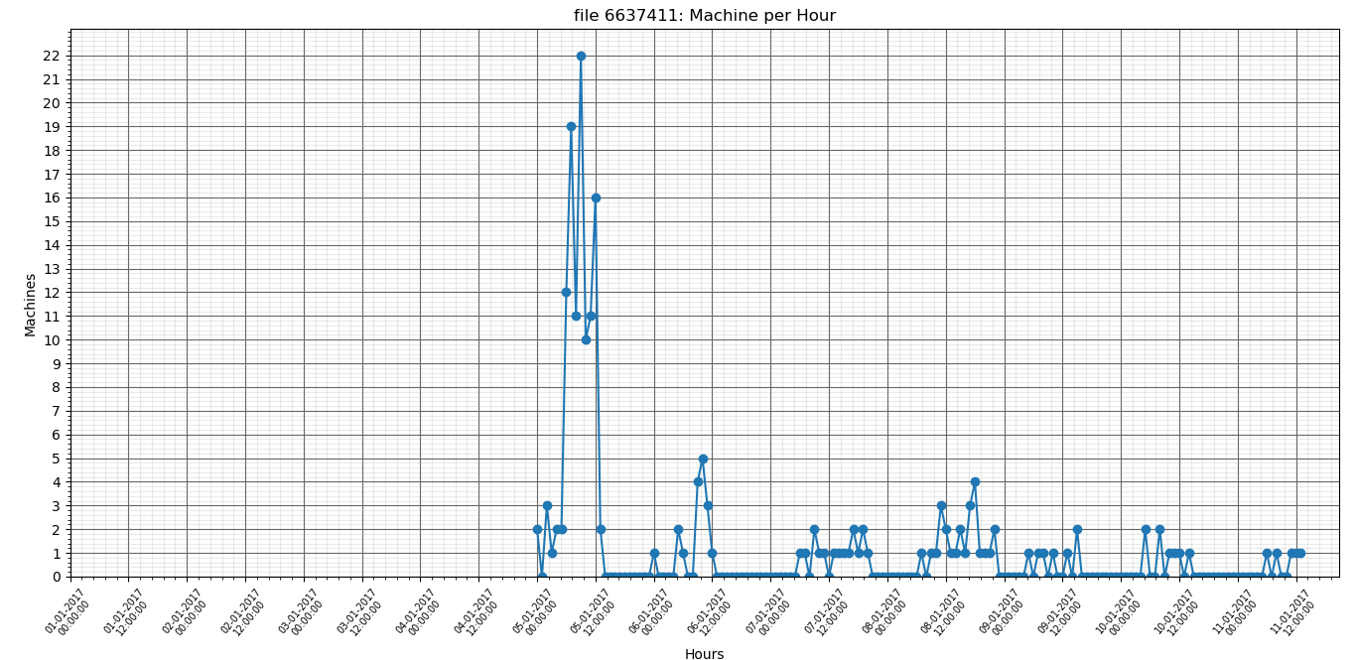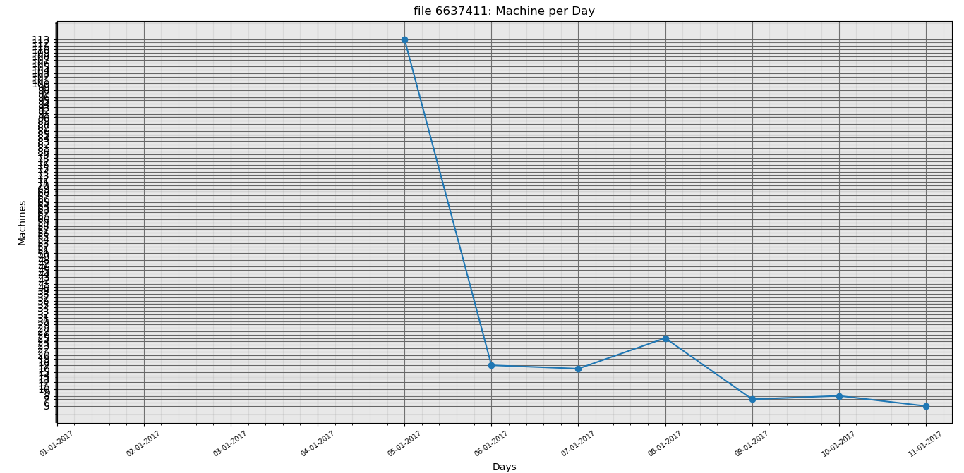

file 6637411: Average machine count per day is: 15.917

file 6637411: Standard deviation is: 31.676

14185271

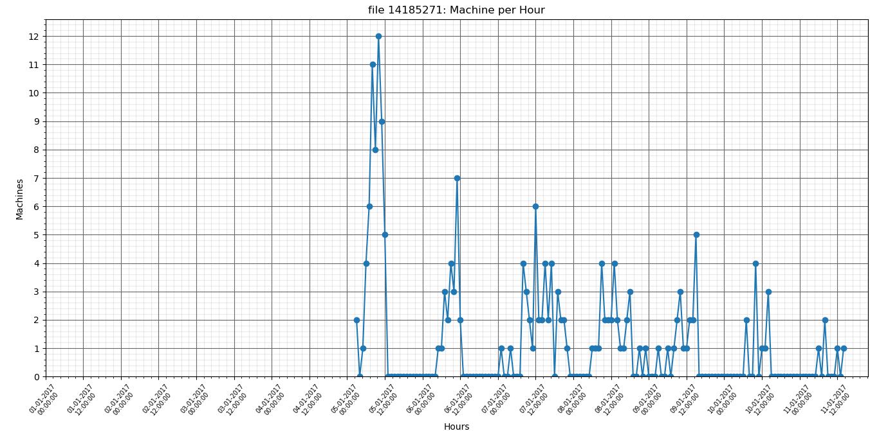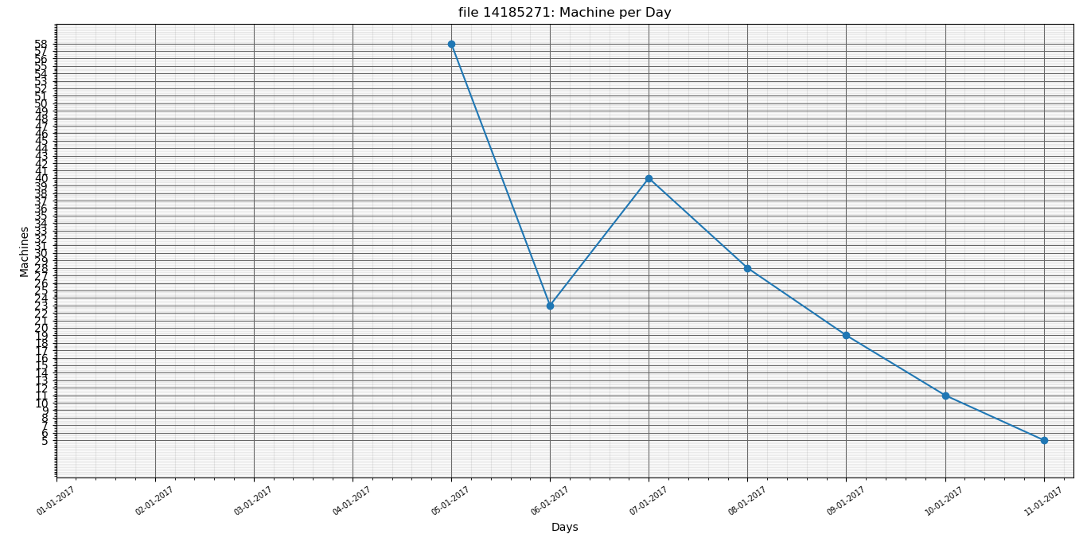

file 14185271: Average machine count per day is: 15.333

file 14185271: Standard deviation is: 18.980

10084066

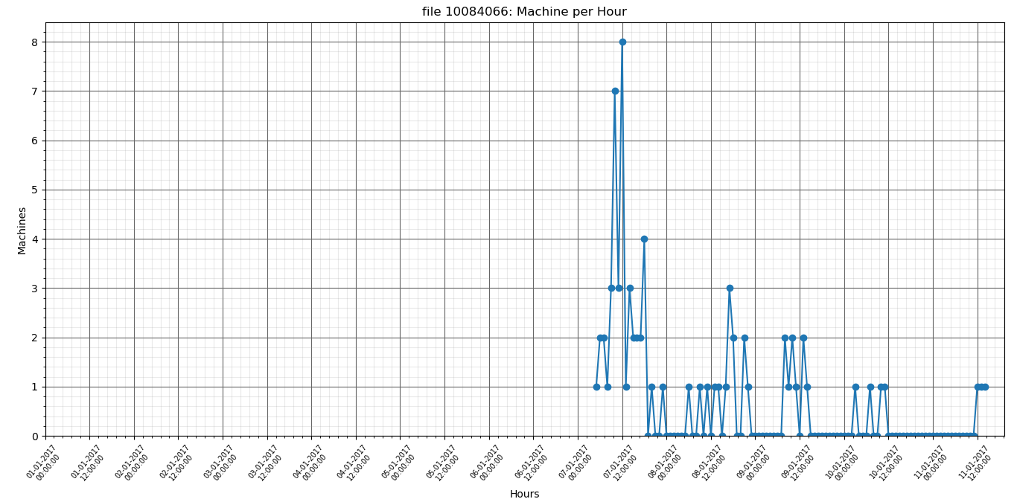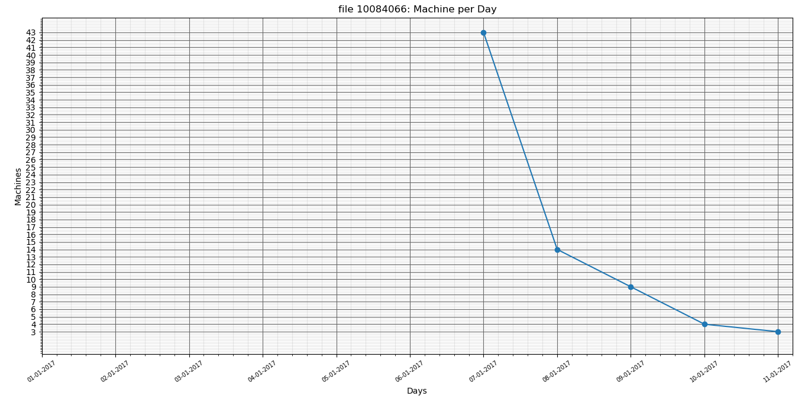

file 10084066: Average machine count per day is: 6.083

file 10084066: Standard deviation is: 12.457

17737433

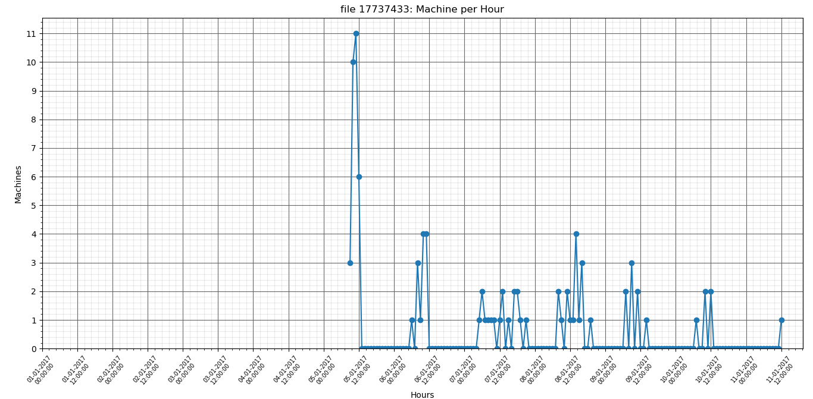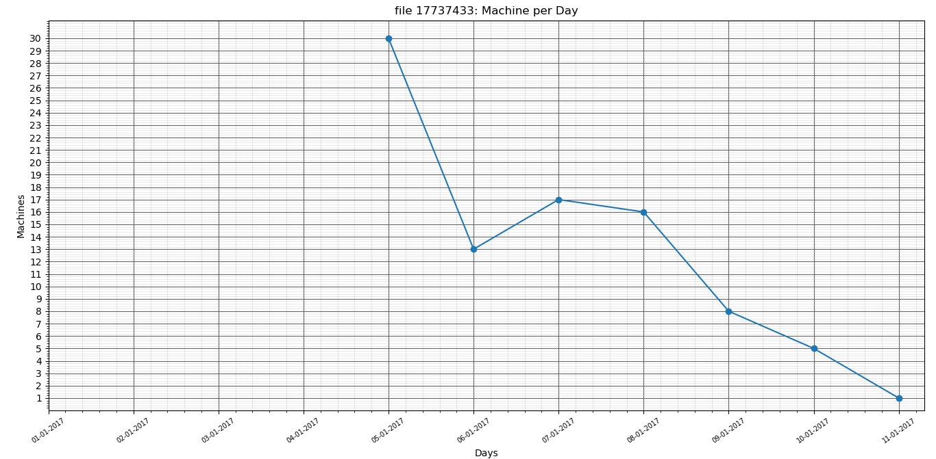

file 17737433: Average machine count per day is: 7.500

file 17737433: Standard deviation is: 9.672

4874387

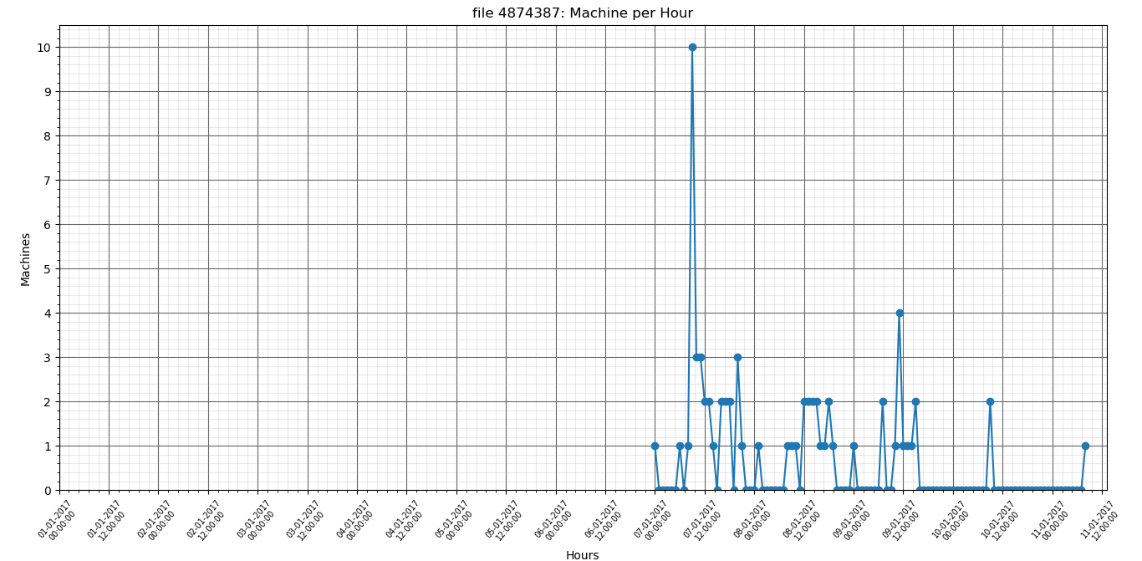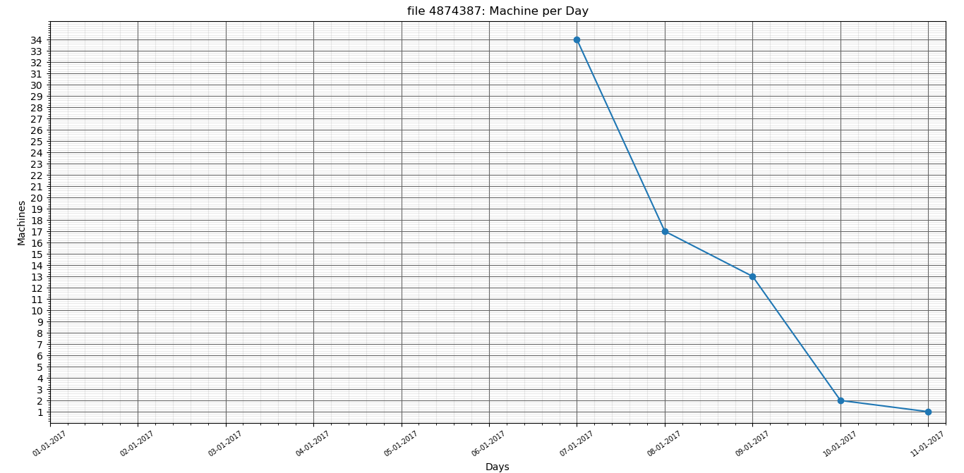

file 4874387: Average machine count per day is: 5.583

file 4874387: Standard deviation is: 10.638

8859052

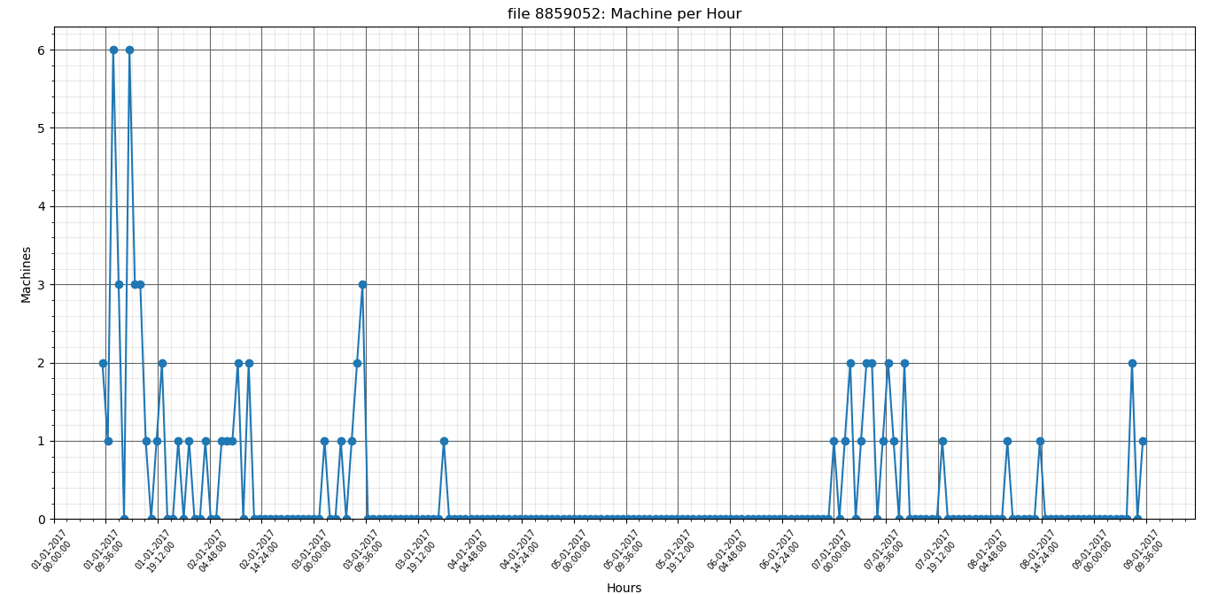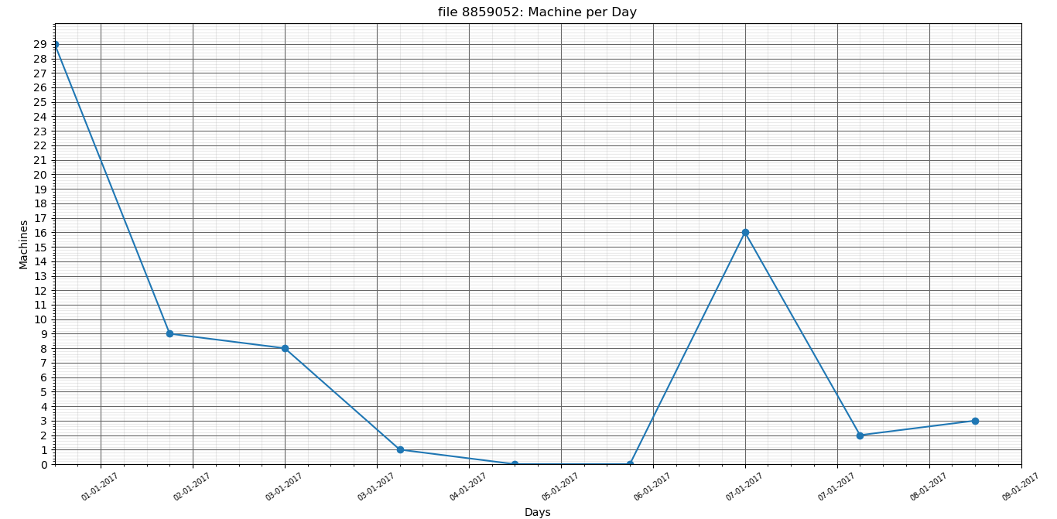

file 8859052: Average machine count per day is: 5.667

file 8859052: Standard deviation is: 8.897

16467840

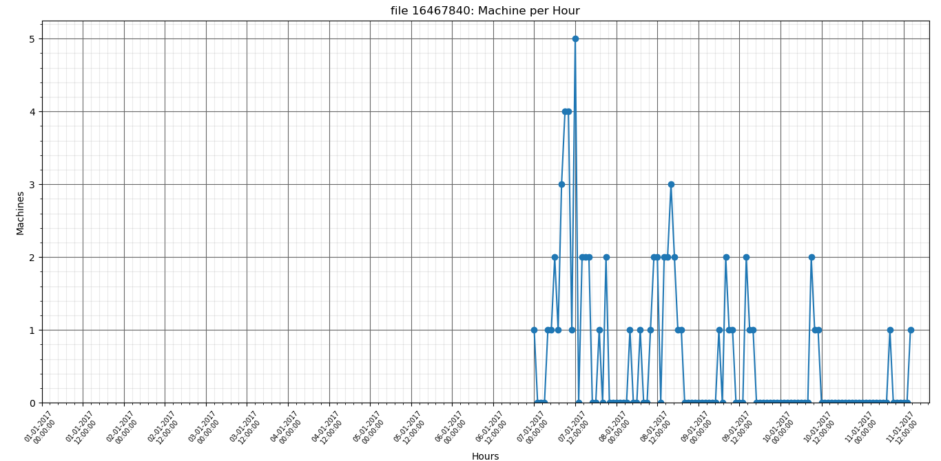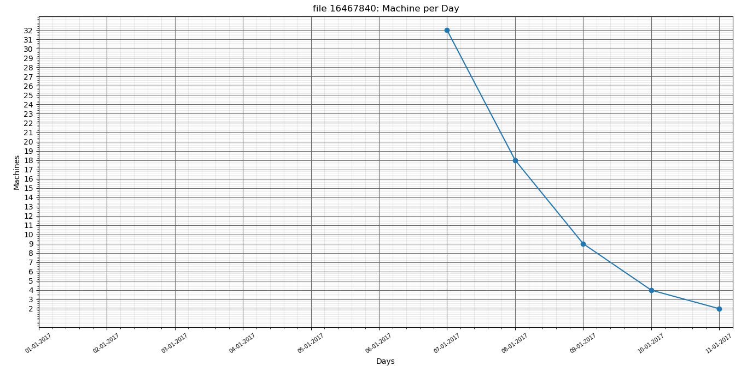

file 16467840: Average machine count per day is: 5.417

file 16467840: Standard deviation is: 9.986